**Final Research Paper**

Cecilia Shields

MIS581-1

Chris den Heijer

July 1, 2022

TABLE OF CONTENTS

Abstract…..…………………………………………………………………………………...3

Introduction…………………………………………………………………………………...4

Objectives…………………………………………………………………………..………...5

Overview of Study..…………………………………………………………………………..5

Research Questions………………….……………………………………………………….6

Hypotheses...………………..…………………………………………………………….....7

Literature Review…………………………………………………………………………...8

Methodology………………..……………………………………………………………....11

Methods….……………………………………………………………………...…………..12

Limitations……………………………..….………………………………………………..12

Ethical Considerations……………………………..….………………………………..…..13

Findings……………………………………………………………………………………..14

Conclusion……………………………..….…………………………………………....…...19

Recommendations…………………………………………………………………………..20

References………………………………………….….…………………………………....21

Abstract

Since the start of the Covid-19 pandemic companies have seen an increase in employees quitting because they are burned out. Stressful times at both work and home while juggling more than ever before have caused people to reevaluate whether they are willing to work at their current corporation. Several hundred people from the United States answered several questions about themselves and their current work situation as well as how burnt out they feel. The analysis conducted looked at what may cause one employee to burnout more likely than another as well as look at how having the ability to work from home affects burnout rate. The data was gathered by Paras Varshney. R Studio and SAS Enterprise Miner were used to conduct the analysis. The analysis found that men and those who work in the service industry are more likely to burn out. A person’s position within the company, their work load and mental fatigue positively correlate with an employee’s burnout rate. The analysis also found that employees that are able to work from home are less likely to burn out. Overall there are numerous reasons an employee may burnout. If a corporation is aware of some of the reasons they may be able to mitigate employee turnover due to burnout. Additional factors may be looked at to ensure an in-depth analysis, but the analysis provided gives corporations a great starting point to see why their employees are burning out.

Introduction

Employees all over the world can be pushed to their limit within a company. Companies that do not understand the balance between work and life or are unaware of the stress they are putting on their employees can push them to burnout. Employee burnout is a “psychological process and occurs due to prolonged stress or excessive work hours” (Pathak, 2021). Companies struggle to see the signs of burnout until it is too late. For the mental health of so many individuals and the success of companies it is important to better understand why an employee is burning out and how to stop this before it happens.

Employee burnout may have seen an increase due to COVID-19 and the additional stressors that came along with the pandemic, but employee burnout has been around for decades. A survey in 2019 showed that twenty three percent of people felt overwhelmed and burned out. An additional forty four percent felt burned out occasionally. In total this shows that almost two thirds of employees feel burned out at some point (Stevenson, 2020). Employees that are suffering not only can have poor mental health, but can also affect overall productivity and decrease what is accomplished at work. In addition, those employees are more likely to look for other jobs and take more sick days. The number of employees who are burning out is on the rise which will overall increase costs for a company and decrease productivity.

In order for a company to successfully navigate the mental health of their employees, they need to have an overall understanding of what type of people burnout and what causes them to burnout. The research that will be done on this topic will provide companies with the knowledge they need to assess whether their employees are at risk for burnout. People are quitting their jobs to work for better companies and make more money. Because of the abundance of jobs available within the market employees are able to move around easier than before. Companies are having to pay more to bring on new employees and watch the ones they have leave. Although not all of this is due to burnout, some of it is and the amount of turnover could be reduced if a company was willing to recognize the problem and make changes.

Objectives

The goal of this research is to provide companies with the necessary information in order to look for burnout among their employees. The data that will be used for the analysis is broken into specific genders in addition to a few other metrics including rank within the company, overall workload, and company type. The data gives a comprehensive view into what may affect an employee burning out. For instance women are at a higher risk for burnout because when they work they are still expected to keep up with household chores and child bearing duties that men are not expected to help with as frequently. Women have been increasingly more likely to burn out at an average of thirty four percent in 2021 versus twenty six percent for men (Saad et al., 2022). Each of these pieces adds to the overall picture of why an employee is burning out.

The data also shows employee satisfaction based on whether they work from home or commute to the office. The pandemic dramatically shifted what the typical work day looked like. Prior to offices being shut down across the world, most companies would have assumed their employees would be more productive in the office, but this is not true. Employees performed as well if not better at home and as offices began to open up employees were reluctant to return to the office. Being able to work from home in addition to the other metrics that will be analyzed within the data will give companies a more guided answer as to why employees are burning out.

Overview of the Study

Since burnout is on the rise it is essential for companies to see the risk and assess which employees might be close to burnout. The purpose of this study is to give companies a better understanding of what to look for. The data collected for the study breaks out employees into several groups which will give employees a lot of beneficial information. Companies will be able to look at an employee's gender, type of company they work for, what rank they have within the company, the amount of work they have to do, their mental fatigue, and their ability to work from home and determine which employees are at risk for burnout. Many companies are losing employees at a rapid pace and need to have better markers so they can help employees not burnout before it is too late.

Research Questions

In order for companies to have a complete understanding of what attributes cause an employee to burnout several questions must be answered. The first research question is what causes an employee to burn out. Within the data set there are several attributes that could potentially answer this question. The data set contains the gender, company type, work from home set up, designation within the organization, resource allocation, mental fatigue, and burn rate. The first six variables listed are what contributes to an employee burning out. Each of those variables individually may not lead to an employee burning out, but when there is a combination of ratings for those variables an employee might be more likely to burn out.

Another research question that would be great to understand would be how does having the ability to work from home correlate to employee burnout. Employees all over the United States are leaving their jobs to find other organizations that would allow them to work from home. A study that was conducted in May of 2021 found that almost forty percent of employees would consider quitting if their employers did not provide flexible remote work (Melin & Egkolfopoulou, 2021). Not being able to work from home or have a hybrid model is already causing employees to leave their job, so it is important to assess whether having a work from home set up or not is causing burnout.

Hypotheses

Both research questions require a hypothesis that will help the reader ascertain whether the researcher answered the research question in the way that the researcher thought or not. “A research hypothesis is a specific, testable prediction about what is expected to happen in a study” (Bhosale, 2021). The first research question is trying to see what factors within the data lead to employee burnout. There are several ways this question can be answered. In order to have a full understanding of the question it would be best to have multiple null and alternative hypotheses to cover each metric that will be looked at. To start with the research will look at gender. The null hypothesis (H0) states females are more likely to burnout than males. The alternate hypothesis (H1) states males are more likely to burn out. Because females are more likely to have to handle household duties as well as take care of any children they might have, the hypothesis is that females are more likely to burnout than males. The next variable to look at is company type. The null hypothesis (H0) states service type companies have a higher burn rate than product type companies. The alternate hypothesis (H1) states product type companies have a higher burn rate than service type companies. Since service type companies have to deal with people interactions more often than product companies, the hypothesis is they will have a higher burn out rate.

The last three hypotheses that will help to answer the overall research question will look at the correlation between the designation within the organization, the resource allocation, and the mental fatigue of an employee. For designation allocation the null hypothesis (H0) states designation will have a negative correlation with the burn rate. The alternate hypothesis (H1) states designation will have a positive correlation with the burn rate.The hypothesis is that employees with a higher title will be less likely to burnout which could be due to the fact that they will have more control over their work environment. For resource allocation the null hypothesis (H0) states resource allocation will have a positive correlation with the burn rate. The alternate hypothesis (H1) states resource allocation will have a negative correlation with the burn rate. The hypothesis is employees that have less work to do will have a lower burn rate. The last piece of the research question looks at the mental fatigue score. The null hypothesis (H0) states the mental fatigue score will have a positive correlation with the burn rate. The alternate hypothesis (H1) states the mental fatigue score will have a negative correlation with the burn rate. The hypothesis is the higher the mental fatigue score the more likely the employee is to burnout. Although there are several pieces of data to test within this one question, this will provide companies with a better understanding of why an employee may burnout.

The other research question looks specifically at the employees ability to work from home. Overall studies in the last two years have shown that it is important for employees to work from home or have a hybrid schedule to improve morale and keep people employed. The null hypothesis (H0) states employees that have a work from home set up have a lower burn rate than employees who do not have a work from home set up. The alternate hypothesis (H1) states employees that do not have a work from home set up have a lower burn rate than employees who do have a work from home set up. It is assumed that the null hypothesis will be accepted, but the statistical analysis will truly confirm or reject it.

Literature Review

Employees have been burning out for many reasons over the years, but company burnout has become increasingly more prevalent due to the Covid-19 pandemic. The research conducted will help a company know what to look for and what employees within their company may be on the verge of burnout, but it does not provide a solution. Kelly Gabriel and Herman Aguinis conducted a study to find what guidelines can be put into place to combat burnout. Gabriel and Aguinis are aware of the negative effect the pandemic had on employees and found what employees want to see from their employers to better their work environment. They found that employees want stress management intervention, flexibility in how their work is conducted, better social support, more ability to make decisions, and higher quality performance management (Gabriel & Anguinis, 2022). This information can be used as a first step after employers have used my research to figure out who they should be worried about within their company. They can then use this information to improve their work culture and reduce the amount of people who are at risk for burnout.

In addition to employee burnout affecting work life, it can also affect the customers. The data is broken out into two main company types, the service industry and the product industry. It is well known that service type jobs can be very strenuous and stressful. Hadar Nesher Shoshan and Sabine Sonnentag conducted a study that looks at the effects of employee burn out on customers. They found that employees that were experiencing emotional exhaustion caused a depersonalisation which had a stronger effect on customer perception than anger and hostility which typically caused customers to retaliate with the same emotion (Nesher Shoshan & Sonnentag, 2020). This is important for companies in the service industry to be aware of. If their employees are burning out they may cause customers to not want to come back or have a mediocre experience which could hurt their business. Since the data I am working with has the company type category, service based companies can look at what factors may cause burnout and improve their company practices to prevent burnout.

One of the categories within the data rates the designation within their company, which includes their responsibilities and the amount of work they have to do. Even if an employee does not have the stress of managing others, there can still be additional stress added on due to empowering leadership. Jan Alam and Muhammad Zaheer describe empowering leadership as companies giving their employees at all levels the ability to lead and take the initiative to better the company. What has been found is that some employees just want to show up and do their job and not work extra hard to grow and change (Alam & Zaheer, 2021). Alam and Zaheer’s study found that empowering leadership can be a cause of employee burnout. Although companies may think they are giving their employees a gift of having more say, not every employee wants this and to help with employee burnout companies should make sure that management is aware of everyone's wanted level of responsibility. This study can also help explain why there is still burnout in lower level employees in my data.

Although empowering leadership may not be the best practice to keep employees from burning out, ensuring ethical leadership may help employees from reaching that point. Shenjiang Mo and Junqui Shi conducted a study that analyzed the importance of ethical leadership. They discovered that employees that have to work in unethical environments have a higher burnout rate (Mo & Shi, 2017). Employees that are expected to cover or look past the unethical tasks their management conducts will burnout much faster than those who have ethical leaders. If a company is using my research to find out why their employees are burning out, but are not seeing any prominent indicators, they may want to look at their leadership.

The data will provide companies with great ways to see why their employees may be burning out. The shortfall of the data that was collected was there were no strong solutions that can be analyzed and then provided to the companies. Once they have the tool to look for who is at risk for burnout they will then need additional information to see the specific cause and what can be done. There are many studies conducted about employee burnout and many provide analysis as to how employers can solve the issue. The research will provide employers with the ability to see where their problem areas are, and these additional studies can provide them with the next steps.

Methodology

The data set that is being used for this research contains quantitative data. The data that was collected was the data an employee joined the company, the gender of the employee, the company type they work for (either service or product), whether they had the ability to work from home, their position within the company, how much work they are producing, their mental fatigue, and their burnout rate. There are nine different columns within the data and each of them are either an integer, ordinal, or binary. Since each item within the data is quantitative, a variety of statistical tests can be done to better understand the data and answer the problem statement. Using quantitative data will allow companies to use the data in the future and answer the same questions that employees had to answer to gauge whether their employees may be experiencing burnout or are about to. The data offers a comprehensive look as to why an employee might have burnout.

Data can be collected in a variety of ways. The data was collected from surveys that were given to employees all over the United States. The data was collected by Paras Varshney and his team and uploaded to Kaggle so others could conduct a comprehensive analysis with the data. His team assigned each person who participated in the survey an employee ID which allowed for anonymity of each person. The data collected and the analysis conducted will provide companies with information as to what types of employees are burning out.

Methods

The next step in answering the research questions is running the statistical methods. There are several different ways these can be conducted. SAS Enterprise Miner and PostgreSQL are both great tools that could be used to understand the data. In order to find out which gender has a higher burn rate SAS Enterprise Miner will be used to create a bar chart that has the average burn rate for each gender. Then the same method can be done to compare the burn rates between product and service type companies. In order to analyze designation, resource allocation, and the mental fatigue score PostgreSQL will be used to run correlation tests on each of the variables with the burn rate. This will not only help answer whether the correlation is positive or negative, but will also let the researcher know how strong the correlation is between the two metrics. SAS Enterprise Miner will also be used to answer the research question regarding the work from home set up. A bar chart will be created which will show the average burnout rate for an employee that has the ability to work from home versus an employee that does not. These statistical tests will help answer the research question and choose whether to accept or reject the null hypothesis.

It is important to keep in mind that in addition to running the statistical tests to answer the research questions, additional analysis will be conducted to understand the data as a whole. The summary statistics will be run and the percentage of the data set that is female versus male will be found. Additional statistical analysis will be conducted in addition to accepting or rejecting the null hypothesis.

Limitations

With any piece of data there are limitations. Even data that is widespread and includes dozens of factors has limitations. There are numerous ways there could be data limitations including missing data, accuracy of information, data collected from a variety of sources, and usability based on limited data, among others (Kamal, 2021). Fortunately the data being used for this research has fewer limitations than others. One large limitation is the lack of additional data. Although there are a few rows of data within this data set, there are less than ten columns. There can be a lot of great analysis conducted on the data, but if there was additional information including hours worked in a week or amount of holidays within the calendar year, this would provide additional insight into why an employee might be burning out.

The other limitation the data has is that since certain things are rated on a scale from one to five or ten based on the employees opinion there could be some inaccurate information due to personal bias. For instance an employee might think that they are incredibly busy and rate themselves as a five out of five, but in reality they do half of the work of someone who rated a three. Obviously everyone’s burnout rate is different therefore everyone’s ratings will be different, but anyone reading the research should still be aware. Most data sets have some sort of limitation that should be noted so those who are using the research are aware of what pieces they may be missing and want to further research independently.

Ethical Considerations

When conducting research it is important to be conscious of the ethical implications that may come along with working with data. “Research ethics matter for scientific integrity, human rights and dignity, and collaboration between science and society” (Bhandari, 2022). A researcher must make sure they are protecting their research participants and ensure that the research is valid and the analysis is done with integrity. The data that is being used is completely anonymous. Each employee is assigned an individual employee ID, but no other specific information is offered. The data was gathered from numerous companies and sources to ensure a wide variety and wide spread anonymity. Additionally, the analysis will include the data source and only the data source to make sure the analysis is not tainted by any other information. It is the researcher’s job to make sure the data used and the analysis done is ethical to make sure that if companies were to use the analysis in the future, the analysis being used is accurate.

Employee burnout is a real problem that many American companies and American employees are facing. This study will provide companies with the insight into why their employees may be burning out and can help them solve the problem before it is too late. There are many pieces and details that go into an in depth research of a particular subject. The data must be obtained either manually or through a database and problem statements can then be written. Once the objectives are decided and an overview of the study is written the research questions and hypotheses can be written. The methodology and methods are then laid out with the limitations and ethical considerations. Each piece lays out exactly what can be expected from the analysis that will be conducted. Once the data analysis has been conducted companies will be able to use the research to understand what is causing their employees to burnout.

Findings

In order to understand the data and confirm or deny the numerous hypotheses SAS Enterprise Miner and RStudio were used. The first step in working with data is understanding how the data was collected and what the data holds. The data was collected by sending hundreds of individuals a questionnaire that asked them questions about their work life. There were a variety of people, both male and female, from all over the United States and worked in a variety of career fields. The data was collected by Paras Varshney. The first step in understanding the data is by running some basic analysis. As seen in Figure 1 the summary statistics were run for the data set to provide an overall understanding of the data.

*Figure 1: Summary Statistics*

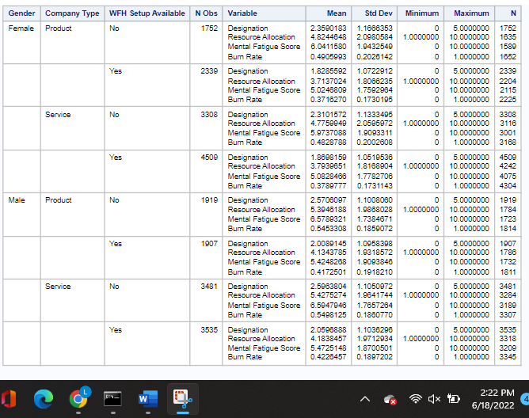

After the basic data analysis was conducted the attention could be moved to answering the research questions and accepting or rejecting the null hypotheses. The first research question and coinciding hypotheses look at what causes an employee to burn out. The first null hypothesis states that females are more likely to burn out in males. In order to start accepting or rejecting the hypothesis it was best to start by understanding the split in data based on the gender. Figure 2 shows the overall breakdown in the study of who is female and who is male. The data is almost a fifty fifty split with about two percent more female respondents. Because the split in the data is almost even the future analysis conducted in regards to the hypothesis will not be skewed one way or the other based on the number of males or females. Based on market research it seemed like the hypothesis would be accepted, but as seen in Figure 3 the average burn out rate for males is considerably higher than for females. The burn out rate is on a scale from zero to one and the average male burn out rate is 0.062 higher than the female burn out rate. Therefore the null hypothesis (H0) should be rejected.

*Figure 2: Gender Pie Chart*

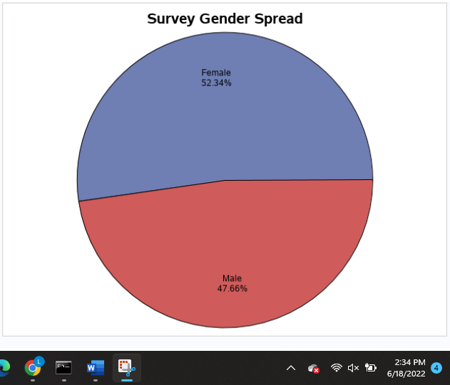

*Figure 3: Average Burnout Rate by Gender*

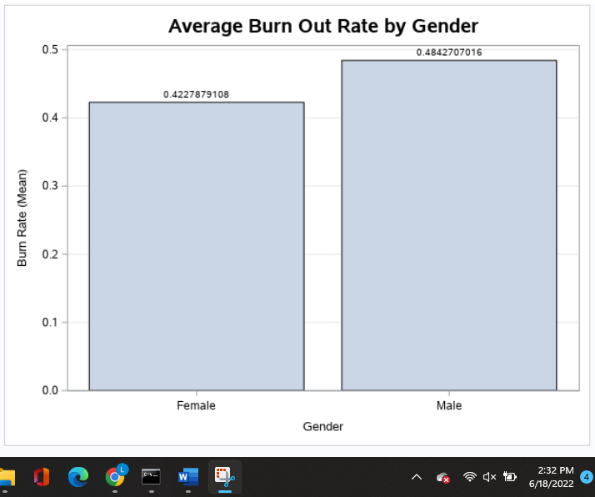

The next null hypothesis states that service type companies have a higher burnout rate than product type companies. Based on research and the fact that service companies tend to have to deal with customers face to face more often than product companies there should be a lower burnout rate for product companies. As seen in Figure 4 the null hypothesis is correct and should be accepted. Although service companies do have an on average higher burnout rate than companies, it is not much higher than product companies. The burnout rate is on a scale from zero to one and there is only a 0.0018 difference between the two. Even though the difference is small the null hypothesis (H0) should be accepted.

*Figure 4: Average Burnout Rate by Company Type*

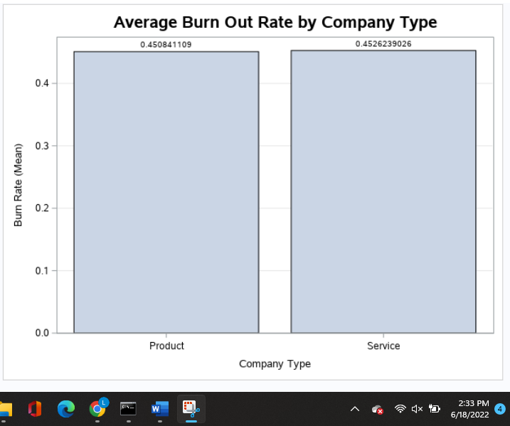

The last three hypotheses for the first business question all look at the correlation between the burn rate and three different variables within the data. The first null hypothesis states that designation will have a negative correlation. The thinking is that lower level employees will have a higher risk for burnout. Figure 5 shows that the null hypothesis (H0) should be rejected. The correlation is positive and quite strong with a correlation of 0.738. The next hypothesis states that resource allocation will have a positive correlation with burn rate. Employees that are given more work will have a higher burn rate. As seen in Figure 5 the null hypothesis (H0) is accepted. The correlation is positive and strong with a correlation of 0.856. The last hypothesis for the first research question is the mental fatigue score will have a positive correlation with the burn rate. Research shows that individuals with more mental fatigue are more likely to stop caring about their job and burnout faster than those who do not. Figure 5 shows that the null hypothesis (H0) should be accepted. There is a strong and positive correlation of 0.945 between the two. Each of these hypotheses helped to answer the research question as to what could be the cause of employee burnout.

*Figure 5: Correlation Analysis between Designation, Resource Allocation, Mental Fatigue Score & Burn Rate*

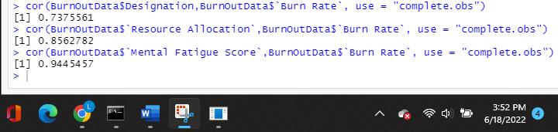

The second research question looks at whether having the ability to work from home decreases employee burnout. Since the pandemic started people have been working from home more frequently and studies have shown that more and more people would rather find another job than return to work in the office full time. The null hypothesis (H0) states employees that have work from home set up available to them have a lower burn rate than employees who do not. Figure 6 shows the average burnout rate for employees that are able to work from home versus those who do not have that option. The burnout rate is on a scale from zero to one and employees that are able to work from home have an average 0.121 lower burnout rate than those who are not able to work from home. The null hypothesis should be accepted. In order to help with employee burnout companies should have a work from home set up.

*Figure 6: Average Burnout Rate with or without Work From Home Setup Available*

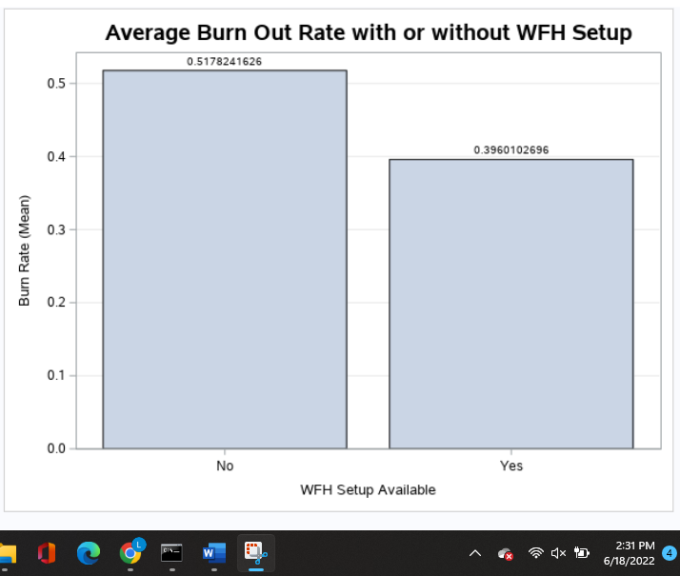

Conclusion

Being able to see the signs of burnout within an employee and recognizing what can be done to deter burnout is incredibly important for companies. Employees are more likely to quit now if they are not satisfied with their company than ever before and it is much more expensive for companies to bring on new employees than keep the ones they have. The data used for this study gathers information from employees all over the United States to figure out what may relate to an employee's burn out rate. The analysis conducted found that men and those who work in the service industry are more likely to burn out. An employee designation, resource allocation, and mental fatigue all positively correlate with their burnout rate. Additionally, employees that have the option to work from home are less likely to burnout than those who do not. This analysis gives companies a general understanding of what they need to watch for within their employees and what adjustments they may be able to make to keep their employees from burning out.

Recommendations

Although the data used for this research provides several great key points, it does not provide a complete picture of why an employee may be burning out. Work/life balance, coworkers, commute length, and many other factors can contribute to whether an employee may be feeling burned out or not. Going forward it may be good to look at some of the additional factors and see how much they attribute to the burnout rate. In addition, companies may want to look at what they can do within their organization to help deter employee burnout. Although helping with the factors discussed can be beneficial it may also be helpful to introduce destress rooms, mandatory breaks, coffee and donut Fridays, and so on. These additional benefits can help balance some of the additional stresses that come along with a job. The research and analysis conducted is a great starting point, but it does not provide all of the answers as to why an employee may be experiencing burnout.

References

Alam, J., & Zaheer, M. (2021). Impact of Empowering Leadership on Employee Burnout: Moderating Role of Emotional Intelligence. *Journal of Managerial Sciences*, *15*, 98–113.

Bhandari, P. (2022, May 7). *Ethical considerations in research: Types & examples*. Scribbr. Retrieved June 7, 2022, from https://www.scribbr.com/methodology/research-ethics/

Bhosale, U. (2021, November 30). *How to write a research hypothesis*. Enago Academy. Retrieved June 8, 2022, from https://www.enago.com/academy/how-to-develop-a-good-research-hypothesis/

Gabriel, K. P., & Aguinis, H. (2022). How to prevent and combat employee burnout and create healthier workplaces during crises and beyond. *Business Horizons*, *65*(2), 183–192. https://doi.org/10.1016/j.bushor.2021.02.037

Kamal, R. (2021, March 10). *Understanding context and the limitations of data*. Tableau. Retrieved June 7, 2022, from https://www.tableau.com/about/blog/2021/3/ data-lessons-learned-during-covid-19-part-two

Melin, A., & Egkolfopoulou, M. (2021, June 1). *Employees are quitting instead of giving up working from home*. Bloomberg.com. Retrieved June 7, 2022, from https://www.bloomberg.com/news/articles/2021-06-01/return-to-office-employees-are-quitting-instead-of-giving-up-work-from-home

Mo, S., & Shi, J. (2017). Linking Ethical Leadership to Employee Burnout, Workplace Deviance and Performance: Testing the Mediating Roles of Trust in Leader and Surface Acting. *Journal of Business Ethics*, *144*(2), 293–303. https://doi.org/10.1007/s10551-015-2821-z

Nesher Shoshan, H., & Sonnentag, S. (2020). The effects of employee burnout on customers: An experimental approach. *Work & Stress*, *34*(2), 127–147. https://doi.org/10.1080/02678373.2019.1577312

Pathak, A. (2021, December 27). *Employee burnout: understanding and tackling it*. Nurture an Engaged and Satisfied Workforce | Vantage Circle HR Blog. Retrieved June 8, 2022, from https://blog.vantagecircle.com/employee-burnout/

Saad, L., Agrawal, S., & Wigert, B. (2022, January 25). *Gender gap in worker burnout widened amid the pandemic*. Gallup.com. Retrieved June 8, 2022, from https://www.gallup.com/workplace/358349/gender-gap-worker-burnout-widened-amid-pandemic.aspx#:~:text=Trend%20in%20percentage%20of%20U.S.,and%20is%2026%25%20in%202021.

Shields, C., (2022). BurnOutData. (n.d.). *R Studio.*

Shields, C., (2022). BurnOutData. (n.d.). *SAS Enterprise Miner.*

Stevenson, M. (2020, January 17). *Employee burnout statistics you need to know*. HR Exchange Network. Retrieved June 6, 2022, from https://www.hrexchangenetwork.com/employee-engagement/news/employee-burnout-statistics-you-need-to-know

Varshney, P. (2021). Are your employees burning out? [Data File]. Retrieved from https://www.kaggle.com/datasets/blurredmachine/are-your-employees-burning-out